Variance in R — 1-Page Summary Report

Problem Statement
Mean, median and mode describe the centre of a distribution but are silent about spread. Two teachers’ grade lists can share an almost identical mean (≈84.4 %) yet tell completely different educational stories: one class is tightly clustered (consistent mastery), the other is highly dispersed (some students excel, others lag). Without a measure of dispersion we cannot see or communicate that difference.

Solution Strategy
1. Visualise the two grade distributions side-by-side. 2. Compute the mean of each. 3. Derive population variance step-by-step (deviations → squares → average). 4. Implement a reusable population-variance function and contrast it with R’s sample var() (N−1). 5. Produce audience-adapted interpretations (analyst vs educator). 6. Supply alternate code paths, extra practice drills, and a Monte-Carlo simulation that lets the learner change true σ and sample size.

Solution
Population variance: σ² = (1/N) Σ(Xi − μ)². Teacher 1: μ = 84.47, σ² ≈ 4.27 (sample s² ≈ 4.41). Teacher 2: μ = 84.30, σ² ≈ 78.13 (sample s² ≈ 80.83) — roughly an 18-fold increase in dispersion. Tiny 5-point example yields manual σ² = 8.16. Monte-Carlo (N=30, true σ=3, 500 sims) recovers mean empirical variance ≈ 8.80 (theoretical 9).
Teacher grade distributions (means marked):
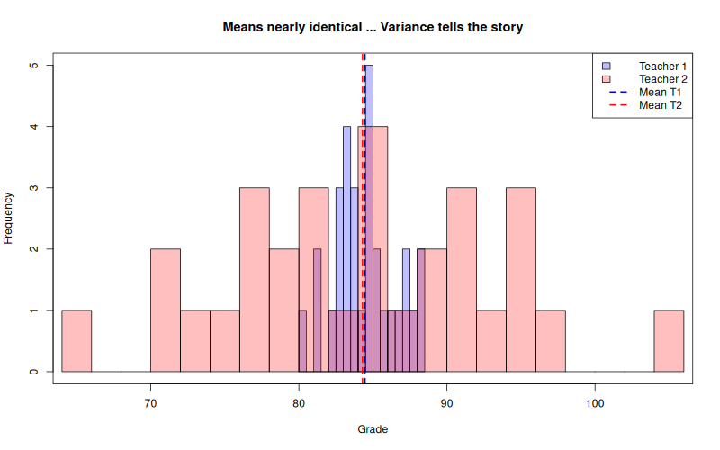
Monte-Carlo recovery of theoretical variance:
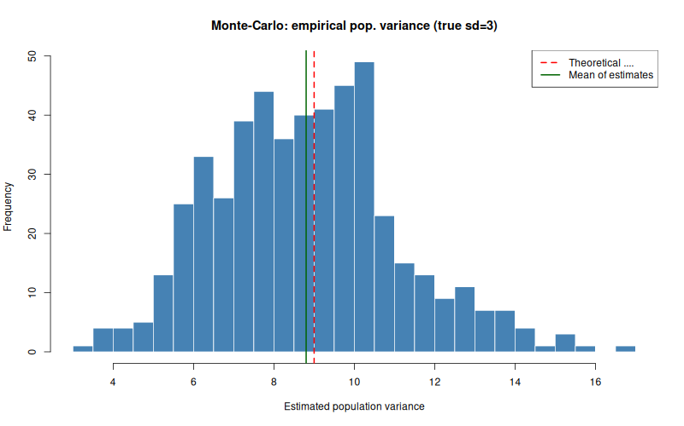

Key Takeaways
• Variance quantifies spread around the mean; two data sets with the same mean can tell opposite stories.
• Squaring deviations makes them positive and weights large deviations more heavily.
• Population formula divides by N; R’s var() (sample) divides by N−1. For N=30 the practical difference is small.
• Adding a constant leaves variance unchanged; multiplying by k multiplies variance by k².
• Always pair the numeric variance (or SD) with a histogram when communicating to non-specialists; technical audiences also want the formula and N vs N−1 distinction.

